Reducing Inequality
perce@harpham.co.nz July 2013
Note that this paper is available at https://dl.dropbox.com/u/92595908/UBIintroduction.doc

Summary
A Universal Basic Income (UBI) has been advocated since about 1800. What is new in this paper is combining that concept with the means of taxation in order to pay for the UBI and to consider the effect on people with different incomes and assets. It is shown that this combination can be used to reduce financial inequality to almost any desired extent by appropriate choice of the variables.

Introduction
Inequality is a matter of more than money. The availability of free swimming pools, health care, education, transport, school meals, parks, child-care and on and on have a great deal to do with equality, or the lack of it, for all people. But money is a part of inequality.

The graph below is from a new book (Inequality a New Zealand Crisis) by Max Rashbrooke and others which shows what has happened in new Zealand since 1984. The top line is the incomes of the top 1% of earners and the bottom line is the income of the bottom 10%. Not only have the bottom 10% become more disadvantaged by the income disparity but the distribution of accumulated wealth is even greater.
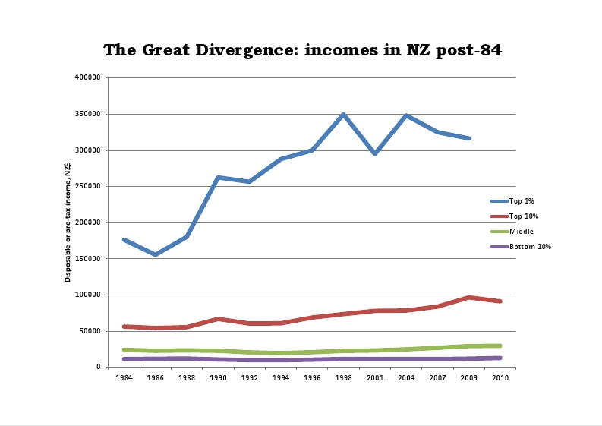

Here I just want to deal with the general availability of money; how much is distributed by Government; how much is taken away and the financial effects on people.

I will show how Government can change the benefit and taxation systems to reduce inequality. The Wilkinson & Pickett book "The Spirit Level - Why More Equal Societies Almost Always Do Better", indicate that Enlightened Self Interest should lead the more wealthy to be just as interested in improving the lot of the less wealthy as the latter themselves.
Reducing inequality is a major feature of the Labour Party’s principles. Article 2 of the Constitution says in part “…the state must ensure a just distribution of wealth.” And, clearly, that is not happening at present in spite of lip service by other partys also.

I will show that the benefit & taxation systems can be greatly simplified with significant savings in administration as well as for the users of the systems.

We can build on two well established examples. These are the current Superannuation system and Local Body rates on properties.

Superannuation is a Universal Basic Income (UBI) which citizens automatically receive after they reach the age of 65. This should be extended to the whole population with a different UBI dependent solely on age.

We will have to find a way to pay for the UBI and again we have an example to build on. This is the fact that Local Body rates are a form of Asset Tax. Governments have been fixated on income but Local Bodies have always been financed by collecting rates based on property values. Governments should learn from Local Bodies. Other forms of tax might be used to finance the UBI but there are particular virtues in an Asset Tax on rateable properties. Such a tax could be collected easily as an addition to rates. WEALTH MUST WORK. And an Asset Tax will help to ensure that wealth is used productively. But first let us concentrate on the UBI.

An unexpected inequality
The step-wise structure of our current income tax is the source of many tax avoidance practices but it also has other consequences. The Auckland economist Keith Rankine has pointed to the way our present tax structure works:

- Income tax on $14,000/year at the current tax rate of 10.5% is $1,470.
- Income Tax on the next $34,000 /year at 17.5% is $5,950
- Income Tax on the next $22,000 /year at 30% is $6,600 - a total of $ 14,020 on the first $70,000.
- Thereafter the tax rate becomes 33%.

The way that the tax system works in steps means that those on the higher rates of tax get the benefit of the reduced rates on lower incomes. For example, if all of a $70,000 income were taxed at 33% the tax would be $23,100 instead of $14,020 - $9080 more than at present. Since the 33% applies to all higher taxes someone on $1,000,000/year is also $9,080/year better off because of the decreased taxes below $70,000/year.

But those below $70,000/year do not get the same financial benefit. And, if we taxed all income at 33% but gave back $9080 to those earning above $70,000/year they would have the same result as at present.

Why dont we give $9080/year to everyone?
What would happen if we did???

We would then have a UBI of $9080/year. The UBI could be at any level but lets use this figure to start with.

Running the numbers
If we set the income tax rate on every dollar of income at 33% and the UBI at $9080/year for 18 to 64 year olds it is easy to see what difference this will make to them compared to the present tax structure.

Taxable | Current | New tax | Old net | New net | Difference
Income | Tax |  | income | income
0 | 0 | 0 | 0 | 9080 | 9080
14000 | 1470 | 4620 | 12530 | 18460 | 5930
48000 | 7420 | 15840 | 40580 | 41240 | 660
70000 | 14020 | 23100 | 55980 | 55980 | 0
100000 | 23920 | 33000 | 76080 | 76080 | 0
200000 | 56920 | 66000 | 143080 | 143080 | 0

The right hand column in the table shows how much better off the 18 to 64 year-olds would be compared to the present with a UBI of 9080/year and a 33% tax if they had other taxable income as shown in the first column.

Note that the UBI is not taxed – it does not count as income - and people’s income is at present taxed at different rates from the 33% depending on the level of income. For example, if one has $14,000 of income apart from the UBI then this income is presently taxed at 10.5% so the present tax is $1470. But at 33% the tax is $4620 ($3150 more). However if one gets a UBI of $9080 then one is better off by $5930 as shown in the table above.

The difference on the right hand side shows that everyone in the 18 to 64 age range with less than $70,000 per year is better off but at $70,000 per year and above there is no difference because that income is presently taxed at 33% anyway.

Clearly this change would reduce the present inequality.

Inequality goes beyond those in the 18 to 64 group. The Commisioner for Children and many organisations have been trying for some years, with increasing desperation, to have the issue of Child Poverty adressed. Working for Families has helped but only where the parents are working and with considerable complexity.

It would be far simpler and satisfactory to replace Working for Families with lower levels of UBI applied to younger age groups including children of those whose parents are not working. Child Poverty would be diminished by this approach. These UBIs would normally be paid to parents or caregivers .

Applying a UBI of $5,000/year to 13 to 17 year olds and $3,000 to younger children as an example we have

Age 13 to 17 (UBI 5000)
Taxable Income 0 14,000 48000 70,000 100,000
Difference 5,000 1,850 -3,420 -4,080 -4,080

Age 0 to 12 (UBI 3000)
Income 0 14,000 48,000 70,000 100,000
Difference 3,000 -150 -5420 -6080 -6080

In all of these examples note that inequality is being reduced. Those with lower incomes are better off while those with higher incomes are worse off. (One might speculate that some children with high incomes gain it through a parent endeavouring to minimize tax.)

I have set up a “spreadsheet” which allows different tax levels and UBIs to be chosen, the resultant Asset Tax calculated and the effect on various groups to be seen. This spreadsheet is available at
https://dl.dropbox.com/u/92595908/UBIspreadsheet.xls
The three pages of the spreadsheet give details of the assumptions and the calculations but the 2nd page allows various UBIs and income tax rate to be inserted at will. The level of Asset Tax required to pay for these is then shown so that one can easily get a feel for the interconnected nature of the three items. The UBIs and income tax rate which are chosen determine the resulting Asset Tax required to pay for them.

Choice of UBI Payments
Of course we are not stuck with any particular level of UBI payments.
If one enters figures into the Spreadsheet the effects are then visible for particular groups and choices of the different levels of UBI can be made so that they conform to ones feelings of fairness. One of the major issues is a comparison with present benefits. The UBI should be high enough for current benefits to be discontinued – although hardship allowances will still be required for particular cases. Another major issue is the level of Asset Tax and its effect on everyone – for example, reducing the effective payment of the UBI for those with some assets such as their own home. I will come to this shortly.

Consider one typical current benefit:

Current Unemployment Benefits/Yr - After Tax for Each Person
Single 18-19 at home $7148.44
away from home $8935.68
Single 20-24 $8935.68
Single 25 + $10722.92
Married, civil union,or defacto
( with or without children) $8935.68

It will be obvious that there is a great temptation to make false claims about one’s status. And that there is then a need to have a costly bureaucracy attempting to detect such claims. People can justifiably feel that they live in a “surveillance state”. With a UBI which depends only on age regardless of ones living arrangements these problems disappear.

It has been well said that unemployment is not working. Apart from being a clever pun this phrase contains a nasty truth. If you do not qualify for Working for Families then if you cannot get a job with 20 hours per week, or more, at the minimum wage then you are foolish to take a job. This is because your benefit is reduced depending on your earnings and with transport costs etc you can be worse off than without a job, The present arrangement for unemployment benefits actively discourages people from seeking work.

With a uniform tax rate and no reduction of the UBI regardless of how much or little one earns then this “poverty trap” disappears. So it may well be that even a single 25+ unemployed person would be better off at a lower rate than the current benefit of $10,658 if they can get even a few hours work per week and no hardship allowance would be required.

There are many things to consider in deciding on the levels of the UBI including how the existing hardship grants should be modified and administered.

Some more benefits of a UBI if we do it right
We can expect many social improvements including:
- A stop to “Beneficary bashing” & official intrusion
- Easy collection of fines and child maintenance
- Reduction of child poverty
- A large saving in the administration costs of benefits
- A reduction in ACC & Student loan problems
- Easier rehabilitation of prisoners
- Improved feelings of security and reduced stress
- An Improved worker/employer power balance
- Improved social cohesion

A UBI would promote an innovation climate in which someone who wanted to start a small business could manage with only a little income from the business and could potentially employ others with the necessary skills for only a few hours at a time and have employment then grow with the business. Each person having a UBI could potentially manage with only a few hours of paid work each week.

Some Principles for the UBI
The UBI must be simple, understandable, effective and easily administered. I suggest the following rules to achieve this:

   The tax rate will be the same for all people, companies and trusts
- The UBI will not depend on living arrangements

- The level of the UBI will depend only on age
- The UBI itself will be tax free

- The level of the UBI will be different for children, youths and adults.
- The UBI will be paid to all citizens of NZ

We can then calculate the costs of the UBI accordingly. But we also have to determine how we will meet those costs.

WEALTH MUST WORK
We are used to the idea that people must work for their living. Equally there should be a responsibility on those who control the wealth and assets of the country to ensure that they are used productively for the benefit of the country rather than simply for private enjoyment. Any tax on assets will encourage the productive use of those assets. If the assets do not earn then the tax will eventually make them disappear.

As noted earlier Government can easily increase the amounts collected by Local Bodies. I propose that all assets which are subject to Local Body rates would have a Government charge added to them – an Asset Tax.
Some advantages of an Asset Tax are:
- The efficient use of capital will be encouraged
- The tax base will be broadened
- Overseas owners will pay the tax
- Inequality will be reduced
- Ostentatious expenditure will be discouraged
- It will be paid by those who can best afford it
- It will be hard to avoid
Most people will be concerned about the application of an Asset Tax to their home.
Some family homes are much more valuable than others. However if family homes are exempted then the tax will fall unfairly on those whose homes are rented. Some 40% of people, mostly poorer people, now rent their home. Any new tax on such homes will, in time, increase the rents. So those without homes of their own will be disadvantaged compared to those with their own homes.

A solution to these problems is to increase the UBI to compensate for the Asset Tax up to a certain level of assets. Suppose we increase the UBI from $9080/year so that anyone with, for example, $200,000 of assets or less was no worse off than if there were no Asset Tax then if two people were in a $400,000 home between them they would not be worse off because of the Asset Tax. Anyone with less than $200,000 of assets would be better off. In the next table I will show the Asset Tax required to fund the UBIs and we will see later that it varies as UBI and Income Tax vary.

With no exemption for a family home the tax would be very easy to administer. No one would have to fill in any forms. The tax would not be avoided by having a child with a “family home”. Property speculation by increasing the value of the family home rather than buying rental property would not be promoted. Questions of multiple ownership would not have to be resolved and so on. Those with more than $200,000 of assets would contribute more to the payment of the UBI and those with less would be better off.

Working with the spreadsheet it is easy to find that if we just vary the UBI for 18 to 64 year-olds (leaving the other age groups unchanged) then with the original 9080 /year the required Asset Tax is $1.4 per $1000 of assets. So someone with $200,000 of assets would be worse off by $280 per year thus reducing the value of the UBI.
But if we increase the UBI to $9660 which is an increase of $580 from the original $9080 then the Asset Tax will have to increase to $2.89 per $1000 of assets or $580 on $200,000 of assets. The same amount as the increase in the UBI.

The table below is taken from the spreadsheet. Different levels of assets from 0 to $5,000,000 are shown across the blue line at the top of the table and different levels of income from 0 to $200,000 per year down the left side. The difference in net income for each level of income and asssets are then shown in the body of the table. For example, someone with $200,000 of assets (about half the average home) with no income would be $9082 per year better off (our $9080 with a $2 rounding error). On the other hand someone with no income but $5,000,000 of assets would be $4802 per year worse off – rising to $13882 per year worse off with $200,000 of income. (An overseas owner declaring no income here would not receive the UBI so would be an additional $9660 worse off.)

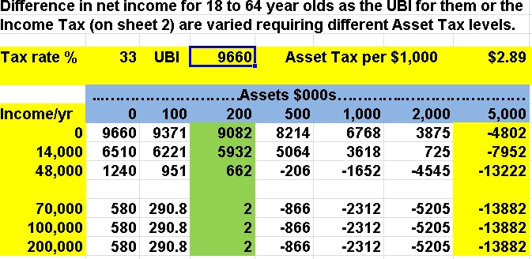

Thus we can choose how much protection to give those with modest, or no, assets while increasing the contribution of those with more assets.. Those on low incomes would have a slightly greater chance of acquiring acquire a home. And those with large assets would be making a greater contribution. We are reducing inequality.

Another example.
The power of a using the UBI, the Income Tax rate, and the Asset Tax to reduce inequality can be further illustrated by considering that we could put the UBI for the 18 to 64 group up to $10,000 per year for example. The Asset Tax would then have to be $3.8 per $1000 of assets. This might be considered to be too high. The answer would then be to increase the Income Tax rate to 35%

The result is that the Asset Tax required is only $1.29 per $1,000 of assets or $258/year for $200,000 of assets.

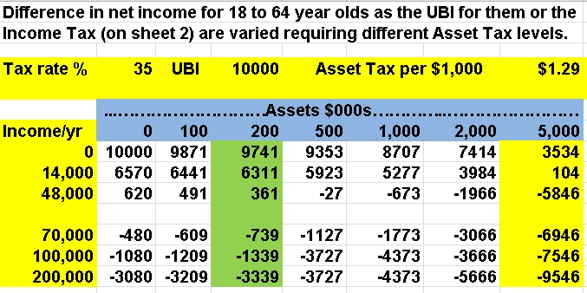

We have brought down the Asset Tax and also now impacted those on incomes over $70,000 because of the higher Income Tax rate while helping those at the bottom. We are now reducing inequality at both ends of the income level although those with a lot of assets may well be better off with the lower Asset Tax as is clear from comparing these two tables. But we could have the higher Income Tax and keep the Asset Tax up as well so as to pay for other things.

Of course we could go further and push the UBI up to, say, $300 per week ($15,600 per year) and the tax rate up to 40%with the following result:
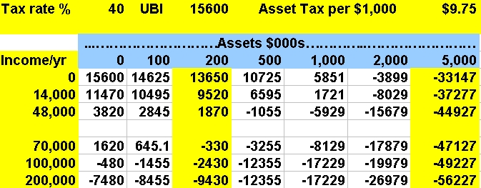

Clearly we can manipulate the figures to give almost any desired result.

Family Income
With UBIs of 10,000 for each adult and $5000 for each teenager a family with two adults and two teenagers would have a total UBI, tax free, of $30,000 per year. If the Income Tax rate was 35% and they had a $400,000 house they would pay $520 per year in Asset Tax. Many other benefits could clearly be abandoned although there would need to be some hardship allowances just as at present but at a much reduced level.

Superannuitants
Superannuation is currently framed on an out of date concept that people who make choices about different living arrangements should get different treatment. Thus single superannuitants, in mid 2013,were given $21,336.64 (before tax) per year if they were living alone but only $19,606.60 if they were “sharing”. Again if they were stupid enough (in a financial sense) to be married they got only $16,137.68 (before tax) each. Because Superannuation is currently treated as income the tax paid on other income is increased and the effective superannuation is diminished.

It is reasonable that those over 65 should have a higher UBI than those who are younger since the more elderly have less chance to add to their income.

However, bringing current superannuation into the UBI framework has an interesting result. If, as an example, superannuation is taken at the married rate for all ($16,137/year) and is both tax free and not counted as income just as the other UBIs then (reverting to a 33% Income Tax)we have the following result for Superannuitants

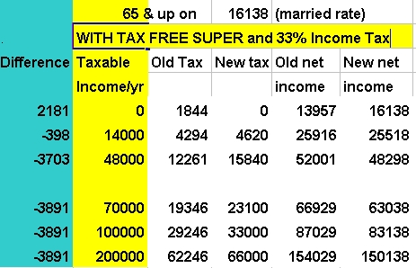

The effects in the table above are, perhaps, surprising but they are a result of “tax creep” where income is pushed into a higher tax bracket. For example, with 14,000 of taxable income, when the super becomes an untaxed and uncounted $16138 the tax is simply 14,000x0.33 = 4,620 which is the new tax. But the old tax is on 16,138 + 14,000 =30,138. Tax on the first 14 000 is at 10.5 % = 1470 and tax on the next 16,138 is at 17.5% = 2,824 totalling 4,294. So the people with 14,000 on top of the super treated as a UBI are $398 per year worse off.

Because there is no tax on the Superannuation then, if one has no other income, one is better off by the amount of the tax that would otherwise have to be paid. But if one has additional income then the 33% rate starts to bite. The effect is, of course, more pronounced with a 35% Income Tax. Again there is a reduction in inequality. Those on $70,000 per year and above of additional income are $3891 worse off but one might well wonder why they need superannuation at all.

I do not have proper data but my rough calculations show that the extra tax from those with additional income more than pays for the loss of tax at the bottom end.of the income range.

Some advocates of a UBI
This is not a new idea. There have been many advocates of UBI. To name just some:
- In their April 2010 newsletter the National Council of Women of New Zealand wrote “NCWNZ policy calls on the Government to ‘investigate the feasibility of introducing a universal basic income for all New Zealanders’. This policy was adopted in 1996, and is as relevant today as it was last century. ”
- Gareth Morgan & Susan Guthrie published “The Big Kahuna” in 2011 with a great critique of our current systems, advocacy of a UBI and a different approach to Asset Tax.
- The Mirrlees committee in the UK finished a two year enquiy into their tax and benefit system and said in part “The holy grail of integrated design, however, has always been the integration of taxes with benefits. The attractions of integrating taxes with benefits …... removes the need to separate out means-tested benefits as a special mechanism”.
- http://economix.u-paris10.fr/pdf/seminaires/H2S/forget.pdf
In this paper Professor Forget traces some United States and Canadian history. In the 1970s the American Government almost adopted a Guaranteed Annual Income as part of President Johnson's "war on poverty". A number of studies were done and the idea was pursued by President's Nixon and Ford but finally lost after President Carter with the election of President Reagan. A Canadian experiment showed many good social effects before the market madness took over.
- BASICINCOME.ORG has a huge number of contributors and ideas.
- Last Year’s Government Welfare Working Group had Treasury consider a UBI of $15,600 a year for 16 and up with $86 per week (4472 per year ) per child. This was to be funded entirely from Income Tax.. It needed 44.4% to 50% income tax and was considered impractical. I agree.
- The German “Pirate Party” has sprung from nowhere to have representatives in each provincial government and 10% of the national vote. Apart from Internet policies it apparently only has a UBI policy.

A Human Right
A UBI can be seen as a natural progression in evolving human rights. People went from being chattels of others through to a notion of freedom, having the right to choose their leaders, for landowners to vote, for all men to vote, for women to
vote also, for a “safety net” and so on.

In this modern age people should be able to live with some dignity as of right.

Summing up
I hope that I have shown that by considering both a UBI and an Asset Tax at the same time we can influence the level of inequality however we choose to do so. And that in the process we can achieve huge simplifications of our systems.

For a more extensive discussion see my paper at
https://dl.dropbox.com/u/92595908/UBIReducingInequality.doc (copy the URL into your browser). Here other possibilites, problems and solutions are discussed such as including other assets like cars, boats and aeroplanes and considering companies and trusts. I would add that one might also choose to give tax rebates to companies for research and development, staff training, child care and other socially desirable ends to compensate for increasing their tax beyond the current level. But by having a uniform rate of tax for all the opportunities for avoidance are greatly diminished.

Government should commit to the development of a UBI. It is of the same significance as that of the 1930s move to social welfare.

A great deal of thought needs to go into the transition to a UBI, its financing and its implementation. There also needs to be a lot of public discussion and education so that the ideas are understood and politically acceptable. Work needs to start on all these things NOW.

perce@harpham.co.nz

